AWS GuardDuty
Tasks
1.
Sign up for a free AWS account (or use an existing one), navigate to AWS GuardDuty in the console, and enable GuardDuty for your region.
2.
Simulate a suspicious activity by generating a failed login attempt in your AWS account, then check GuardDuty to see if it detects and logs the event.<br><br><em><strong>Hint:</strong> Try logging in with the wrong password multiple times or use the AWS CLI to attempt unauthorized actions.</em>
3.
In Azure, access the Security Center and enable threat protection for a virtual machine or resource group, then review the dashboard for any security alerts or recommendations.
4.
Compare the types of threats detected by AWS GuardDuty and Azure Security Center by listing 3 examples each, based on your exploration of their dashboards and documentation.
5.
Describe, step-by-step, how real-time threat detection works in either AWS GuardDuty or Azure Security Center, using a scenario like detecting a brute-force attack on a cloud resource.

Answer : Task 1: Enable AWS GuardDuty
What is AWS GuardDuty?
AWS GuardDuty is a threat detection service that continuously monitors your AWS account for suspicious activities using AWS logs, DNS logs, and machine learning.
Steps
Step 1: Create or Log in to AWS
- Go to the AWS Management Console.
- Sign in using your AWS account.
- If you don't have an account, create a free AWS account.
Step 2: Open GuardDuty
- In the AWS Console search bar, type GuardDuty.
- Click Amazon GuardDuty.
Step 3: Enable GuardDuty
- Click Get Started or Enable GuardDuty.
- Select your AWS Region (for example, US East (N. Virginia)).
- Click Enable GuardDuty.
Step 4: Verify
You should see:
- GuardDuty Status: Enabled
- Dashboard showing findings (currently 0 if nothing suspicious has happened).

Task 2: Simulate Suspicious Activity

Method 1 (Easiest)
Attempt several failed AWS Console logins.
- Open AWS login page.
- Enter the correct username/email.
- Enter an incorrect password.
- Repeat about 5–10 times.
Note:
GuardDuty may not immediately create a finding for console login failures because it focuses mainly on AWS resource activity, API calls, network traffic, and threat intelligence. Multiple failed console logins are usually recorded in CloudTrail or CloudWatch, but they do not always trigger a GuardDuty alert by themselves.

Method 2 (Better)
Use AWS CLI.
Example:
aws s3 ls --profile fakeuser
or
aws iam list-users
using invalid credentials.
This creates unauthorized API calls.
Wait 10–30 minutes.

Check Findings
Go to
GuardDuty → Findings
If detected, you'll see alerts such as:
- UnauthorizedAccess
- Recon activity
- Credential compromise

Task 3: Enable Azure Security Center (Microsoft Defender for Cloud)
What is Azure Security Center?
It helps protect Azure resources by detecting threats, security weaknesses, and configuration issues.

Step 1
Log into the Azure Portal.

Step 2
Search for
Microsoft Defender for Cloud
(formerly Azure Security Center)

Step 3
Click
Environment Settings

Step 4
Choose your Subscription.

Step 5
Enable Microsoft Defender Plan.
For example:
- Defender for Servers
- Defender for Storage
Click Save.

Step 6
Go back to
Overview Dashboard
You will see:
- Secure Score
- Recommendations
- Security Alerts
- Regulatory Compliance
If you already have a VM, select it and enable Defender protection.

Task 4: Compare AWS GuardDuty and Azure Security Center
AWS GuardDuty | Azure Security Center (Microsoft Defender for Cloud)
Detects brute-force SSH login attempts | Detects brute-force attacks against Azure VMs
Detects suspicious API calls using stolen credentials | Detects malware running on virtual machines
Detects communication with known malicious IP addresses | Detects vulnerable configurations and missing security updates

Short Comparison
AWS GuardDuty
- Focuses on threat detection.
- Uses CloudTrail, DNS logs, and VPC Flow Logs.
- Provides security findings.
Azure Security Center
- Focuses on both threat detection and security posture.
- Gives recommendations to improve security.
- Calculates Secure Score.

Task 5: How Real-Time Threat Detection Works (AWS GuardDuty Example)

Scenario: Brute-Force Attack on an EC2 Instance
Step 1
An attacker starts making many SSH login attempts to an EC2 server.
↓
Step 2
AWS automatically records network traffic and API activity using:
- VPC Flow Logs
- CloudTrail
- DNS Logs
↓
Step 3
GuardDuty continuously analyzes these logs using:
- Machine learning
- Threat intelligence feeds
- Behavioral analysis
↓
Step 4
GuardDuty notices:
- Many failed SSH login attempts
- Unusual login pattern
- Source IP is known to be malicious
↓
Step 5
GuardDuty creates a Finding.
Example:
UnauthorizedAccess:EC2/SSHBruteForce
↓
Step 6
The finding appears in the GuardDuty Dashboard.
It includes:
- Severity level
- Time detected
- Source IP address
- Affected EC2 instance
- Description of the threat
↓
Step 7
The administrator investigates and responds by:
- Blocking the malicious IP
- Changing passwords or SSH keys
- Updating security group rules
- Reviewing CloudTrail logs
- Monitoring for additional suspicious activity

Summary
- Task 1: Enable GuardDuty from the AWS Console.
- Task 2: Generate unauthorized activity (failed logins or invalid AWS CLI requests) and check GuardDuty findings.
- Task 3: Enable Microsoft Defender for Cloud on your Azure subscription or VM and review alerts and recommendations.
- Task 4: Compare GuardDuty (threat-focused) with Defender for Cloud (threat detection + security posture).
- Task 5: Real-time detection works by collecting logs, analyzing them with machine learning and threat intelligence, generating a finding, and allowing administrators to investigate and respond.

AWS GuardDuty Dashboard Example
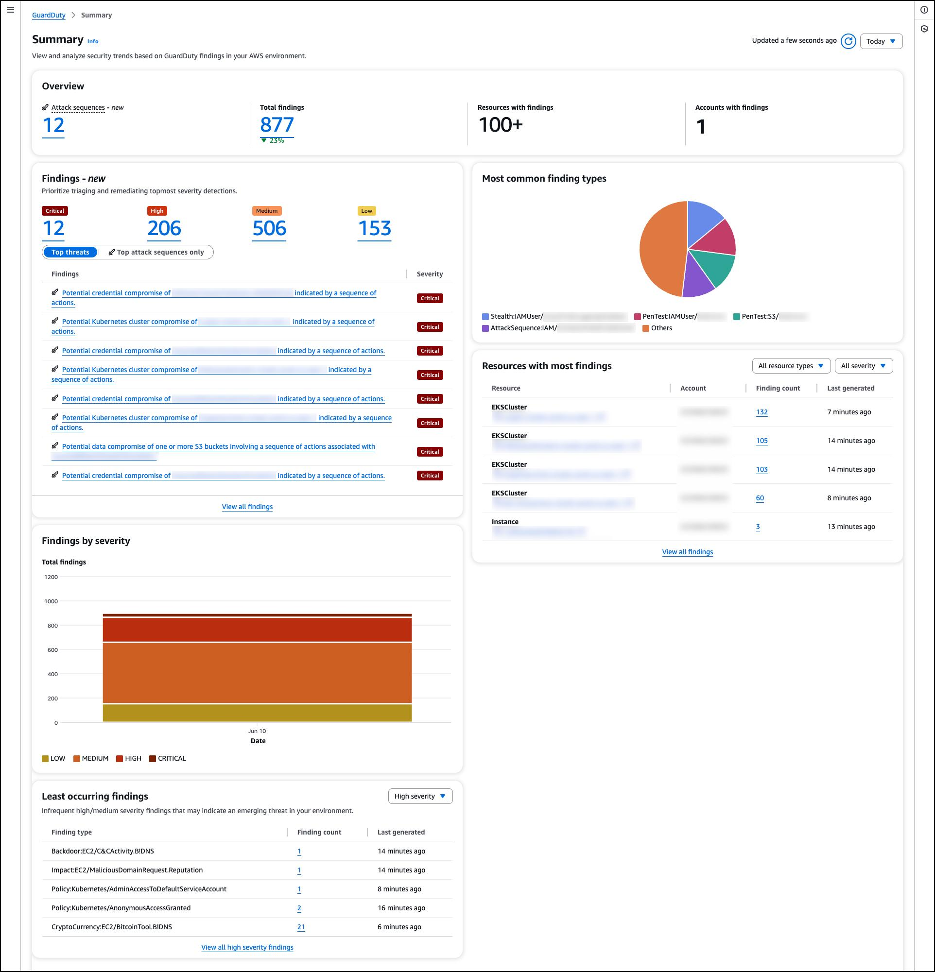
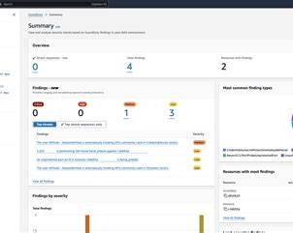
The GuardDuty dashboard shows:
- Total security findings
- Findings by severity (Critical, High, Medium, Low)
- Most common threat types
- Resources affected (EC2, IAM, S3, etc.)
- Recent security findings

Example Finding
Threat Type
UnauthorizedAccess:EC2/SSHBruteForce
Severity: High
Description:
GuardDuty detected multiple failed SSH login attempts from a suspicious IP address trying to access an EC2 instance.
Recommended Action:
- Block the attacker's IP.
- Change SSH credentials.
- Review CloudTrail logs.
- Update Security Groups.

Azure Microsoft Defender for Cloud Dashboard Example
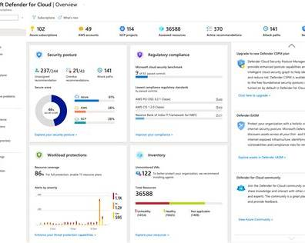
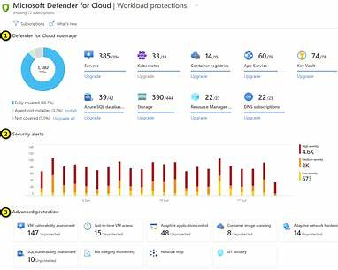
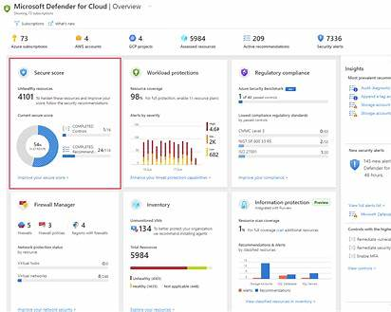
The Microsoft Defender for Cloud dashboard includes:
- Secure Score
- Security Alerts
- Recommendations
- Regulatory Compliance
- Workload Protection
- Resource Inventory

Example Security Alert
Alert Name
Possible brute-force attack detected
Severity: High
Affected Resource:
Virtual Machine (VM)
Description:
Several failed Remote Desktop Protocol (RDP) login attempts were detected from the same IP address, indicating a possible brute-force attack.
Recommended Action:
- Enable Multi-Factor Authentication (MFA).
- Block the malicious IP.
- Change administrator passwords.
- Enable Just-In-Time VM Access.

Example Comparison Table
AWS GuardDuty | Microsoft Defender for Cloud
Detects SSH brute-force attacks | Detects RDP brute-force attacks
Detects suspicious API calls | Detects malware on Azure VMs
Detects communication with malicious IPs | Detects missing security patches and configuration issues

Example Scenario: AWS GuardDuty Detecting a Brute-Force Attack

Attacker
│
│ 100+ SSH Login Attempts
▼
EC2 Instance
│
▼
VPC Flow Logs + CloudTrail
│
▼
AWS GuardDuty
│
Analyzes logs using:
• Machine Learning
• Threat Intelligence
• Behavior Analysis
│
▼
Creates Finding
"UnauthorizedAccess:EC2/SSHBruteForce"
│
▼
Administrator Receives Alert
│
▼
Blocks IP Address
Updates Security Group
Changes SSH Keys

Example Findings You Might See

AWS GuardDuty
Finding | Description
UnauthorizedAccess:EC2/SSHBruteForce | Multiple failed SSH login attempts detected
Recon:EC2/PortProbeUnprotectedPort | An attacker is scanning open ports on an EC2 instance
CryptoCurrency:EC2/BitcoinTool.B!DNS | An EC2 instance may be communicating with cryptocurrency mining infrastructure

Microsoft Defender for Cloud
Alert | Description
Brute-force attack detected | Multiple failed RDP or SSH login attempts
Malware detected | Malware found on a virtual machine
Vulnerability assessment | Missing patches or insecure configurations identified

